附件4：英文摘要参考模板 (Template for English Abstracts)

Discovery of XXX
Pinglin Li^{1,*}, XXX², XXX¹, XXX¹, XXX¹
¹ Key Laboratory of Marine Drugs of Ministry of Education, School of Medicine and Pharmacy, Ocean University of China, Qingdao 266003, China. ² College of Chemistry and Chemical Engineering, Ocean University of China, Qingdao 266003, China.
* Correspondence: Tel: 0532-820311535; Email: lipinglin@ouc.edu.cn
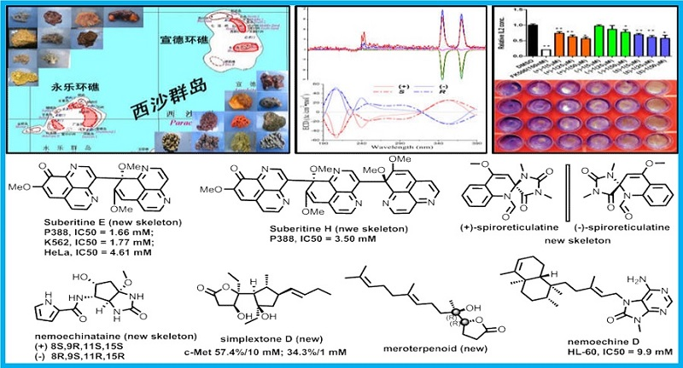
Abstracts Content: XXXXXX

No more than one page for English Abstracts

Reference:
1. Qi Wang, Xuli Tang, Xiangchao Luo, Nicole J. de Voogd, Pinglin Li, and Guoqiang Li. (+)- and (−)-Spiroreticulatine, A Pair of Unusual Spiro Bisheterocyclic Quinoline-imidazole Alkaloids from the South China Sea Sponge Fascaplysinopsis reticulate. Organic Letters, 2015, 17, 3458−3461
2. Jinrong Zhang, Xuli Tang, Jing Li, Peifeng Li, Nicole J. de Voogd, Xiaoqin Ni, Xiaojie Jin, Xiaojun Yao, Pinglin Li and Guoqiang Li. Cytotoxic Polyketide Derivatives from the South China Sea Sponge Plakortis simplex. Journal of Natural Products, 2013, 76(4):600-606.
3. Caixia Liu, Xuli Tang, Pinglin Li, Guoqiang Li. Suberitine A-D, Four New Cytotoxic Dimeric Aaptamine Alkaloids from the Marine Sponge Aaptos suberitoides. Organic Letters, 2012, 14(8):1994-1997.

